



**Table of Contents**

1. **Introduction**…………………………………………………………………………3
   1. Purpose…………………………………………………………………………...3
   2. Scope……………………………………………………………………………..3
2. **General Description**....……………………………………………………………...4
   1. Product Functions….………………………………………………………….....5
   2. User Characteristics………………………………………………………….......5
3. **Specific Requirements**……………………………………………………………...5
   1. Functional Requirements….……………………………………………………..6
   2. Non-Functional Requirements…………………………………………………...7
4. **Analysis Models**……………………………………………………………………..
   1. Use Case Diagram………………………………………………………………
   2. Class Diagram…………………………………………………………………...
5. **Screens**………………….………………………………………………………….10
6. **Database (ERD)**…………………………………………………………………....
   1. Database Schema….………………………………………………………….....
7. **Web Calls**………....…….…………………………………………………………..
8. **References**…………………………………………………………………………..
9. **Glossary**……………………………………………………………………………28
10. **Introduction**

Room Booking Mobile Application is a modern digital booking system that enables Teachers, Pedagogical Counsellors as well as other Staff members in CEGEP’s Montreal campus to book a room either for an exam or a meeting. Room Booking Application is essential in an office environment because scheduling the shared spaces in a busy office can be a challenge. So this application is specially designed for the purpose of self-service booking. This application is an easy-to-use room booking tool with a simple and organized overview of the availability of the rooms to prevent miscommunication and scheduling conflicts.

* 1. **Purpose**

The main purpose of this application is to make it easy for users to find a perfect room for upcoming meetings or for exams based on it’s capacity, amenities like hardware equipment and software equipment. This application improves the utilization of rooms with a hassle-free environment and also provides the platform for flexible room management.

* 1. **Scope**

1. The mobile application that we will design will be identified by the name *Room Booking Application*.
2. The objective of this application is to provide a better place to manage the rooms and utilize the room space effectively.
3. Teachers, Pedagogical Counsellors and other staff members in CEGEP’s Montreal campus will be able to use this application to book a room either for an exam or for a meeting.
4. This app is available on the mobile devices that run on Android OS.
5. Features that will be implemented in this application:

* This application will list all the available rooms, to the user.
* Users will book a room for an exam or for a meeting with just 2 clicks of a button.
* Users will see the capacity of the available rooms listed to them.
* Users will see the software equipment and hardware equipment in each available room.
* Users will be able to cancel the booked room.

1. Future Scope of this application:

* This application can allow users to report faulty equipment in the booked room.
* Users can customise the meeting by requesting for additional equipment, users can name their meeting.
* Admins of the application can add feedback options and get feedback from users after they utilize the room space. It will allow admins to manage the room space better.
* Users can send invitations to students or other colleagues to attend the exam or meeting.
* Users can get reminder notifications before the meeting.
* The rooms booked by the users can be cancelled automatically if they didn’t check-in within the timeframe.To do this we can set up a QR code scanner which will allow users to check-in into their booked room by scanning in their mobile.

1. **General Description**

Room Booking App is a modern digital booking system designed for managing, booking exam rooms and conference rooms in CEGEP montreal campus. Smart technology enables effective management and planning of college meetings, makes college processes simpler and helps to use company space in a better way. Colleges are often facing problems with availability of meeting rooms; either they have to deal with overbooked rooms or unused spaces. This can cause confusion and lost time. Thanks to this application you will have an instant overview of the availability of a particular room – simple, easy and stress-free. Users can book a meeting directly on their mobile on their way to work. It takes just a tap or two. All information about rooms availability, booked rooms are centralized and digitized.

* 1. **Product Functions**

Room Booking Application should be an easy to use application which will offer a user friendly process for booking a room. From booking rooms to updating profile details, cancelling booked rooms, viewing available rooms can be done by the user with few computer clicks. Additionally the admin can also add new rooms, view booked rooms, view available rooms, Edit room details within this app.

Room Booking application is supposed to be a mobile based application.

* 1. **User Characteristics**

Room booking application will target different kind of users in CEGEP’s Montreal campus:

* Teachers
* Pedagogical counsellors
* Other staff members in CEGEP’s Montreal campus

1. **Specific Requirements**

The requirements of this mobile application outlines the needs of the users who will use this app. It compiles all the below-listed functional and non-functional requirements and becomes the base reference document for our entire development team.

These requirements list out the technical specifications, and the list of assets(hardware, Third-party softwares) connected with the app.

* 1. **Functional Requirements**

Functional requirements specify a function that this application must be able to perform. It can be documented in various ways. It may be Technical details, Data processing and Other specific functionality.

|  |  |  |  |
| --- | --- | --- | --- |
| **Requirement ID** | **Requirement Statement** | **MUST/SHOULD/COULD/WOULD** | **Comments** |
| FR1 | The application shall have a login screen as a home page. | MUST | The system shall verify the credentials with the database. |
| FR2 | The application shall have a registration page, where the user/staff can enter the details. | MUST | The system shall save the data within the database. |
| FR3 | The Users/staff shall be able to edit/update their profile details. | COULD | The system shall update the profile details of the user in the database. |
| FR4 | The application allows the admin/user to view the list of available rooms. | MUST | The system shall fetch the data of rooms available from the database. |
| FR5 | Users can book a room based on purpose of booking, capacity, hardware/ software requirements. | MUST | The system shall book a room according to the user requirement. |
| FR6 | Users can see their booked rooms, date and duration of exam or meeting. | MUST | The system shall fetch the booked rooms by the user from the database. |
| FR7 | Users can cancel the rooms that are already booked by them. | MUST | The system shall update the room details once the room is cancelled by the booked user. |
| FR8 | The User shall have the option of Log out. | MUST | The system shall log out the user from the application. |
| FR9 | The application allows the admin to add the rooms, hardware/software equipment. | MUST | The system shall add rooms, hardware/software equipment in the database. |
| FR10 | The application allows admin to cancel room booking. | MUST | The system shall cancel room booking and update it’s details in the database. |
| FR11 | Admin can edit/update the room details (Room number, Room capacity, Hardware equipment, Software equipment). | MUST | The system shall update the room details in the database. |
| FR12 | Admin can view the booked rooms. | SHOULD | The system shall fetch the details of all booked rooms from the database. |
| FR13 | Admin can view the list of all the rooms(both available & booked rooms). | SHOULD | The system shall fetch the details of all rooms from the database. |
| FR14 | Allow admin to delete the rooms from the app. | MUST | The system shall delete the room details from the database. |
| FR15 | Users can View the date of the meeting or exam. | SHOULD | The system shall display the date for the booked room. |

**3.2 Non-Functional Requirements**

NFR1. The platform must be Android and the minimum version should be 4.0.3 with API(Application programming Interface) level 15.

NFR2. Users should be able to navigate quickly between screens( maximum time is 2 seconds).

NFR3. This App should be able to handle 400 users at a time without affecting its performance or accuracy.

NFR4. Users should be able to navigate easily within the app.

NFR5. The content in the app must be comprehensible.

NFR6. The app should be alluring to provide a user-friendly environment.

NFR7. The app must be available for 24/7.

NFR8. The language used in the first version is English. Later, we would add more language options(French, Hindi).

NFR9. The app should be responsive to the user input.

NFR10. The admins of this app can add more rooms, more amenities, more features in future.

NFR11. The admins of this app can update the Terms and Conditions of the app in future.

1. **Analysis Models**

We are using three analysis and design models to develop our requirements into a mobile application.

**Use case Diagram**

***To be Done***

**Class Diagram**

***To be Done***

* 1. **Use case Diagram**

***To be Done***

* 1. **Class Diagram**

***To be Done***

1. **Screens**

**Screen flow diagram**



**Screen Design**

We can simulate the screens of the app in this tool and verify how it looks when the App is designed. We use drag and drop widgets, screens to design the screens. We used Justinmind Prototyper 8.7.0 to design the Screens. We can simulate these screens with this tool or we can view on our mobile device by connecting it.

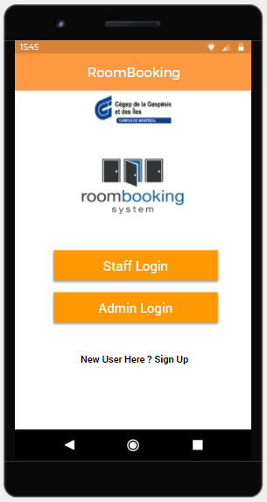

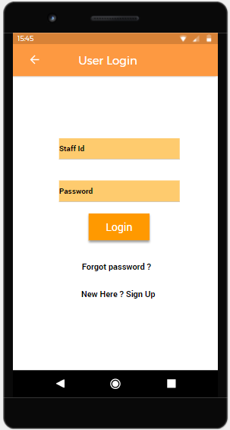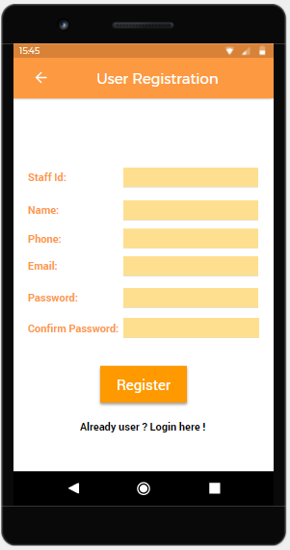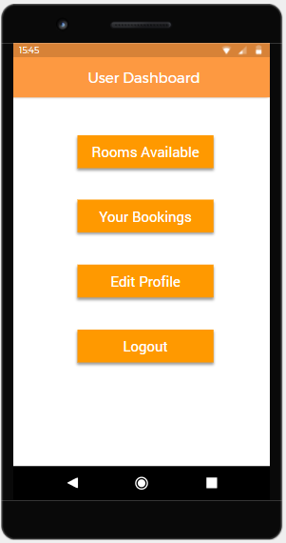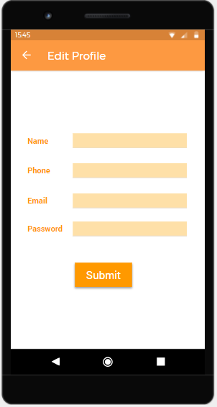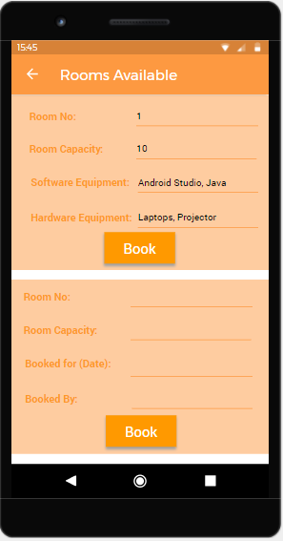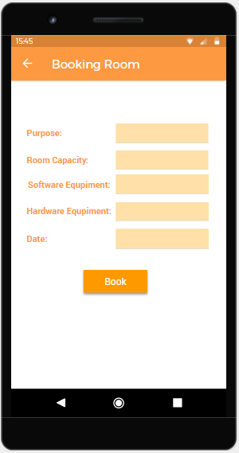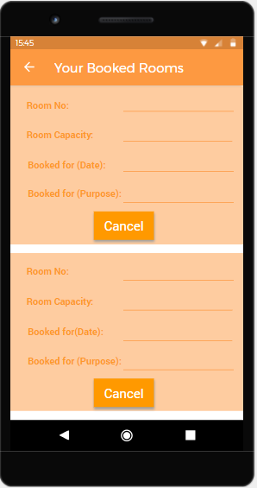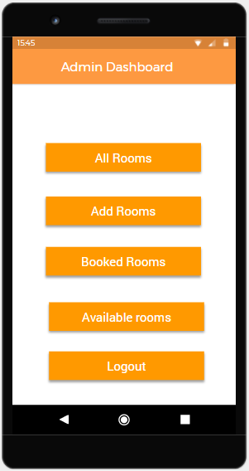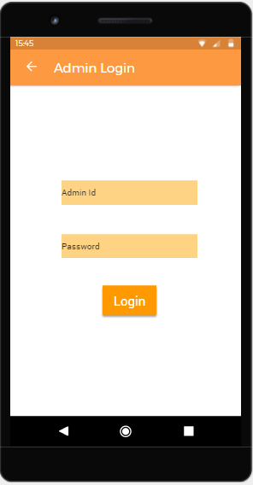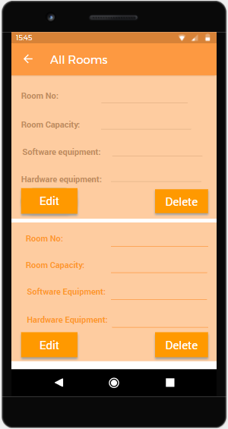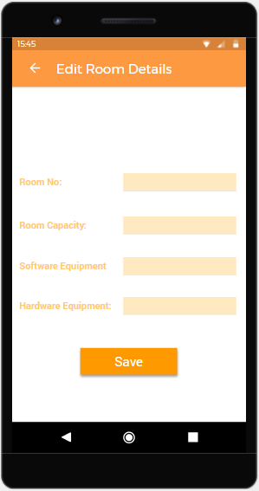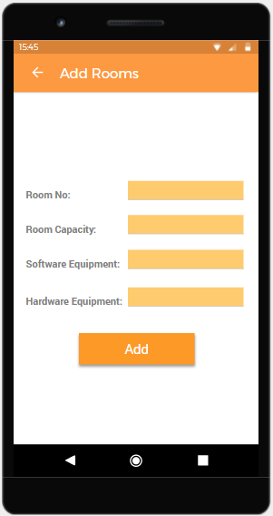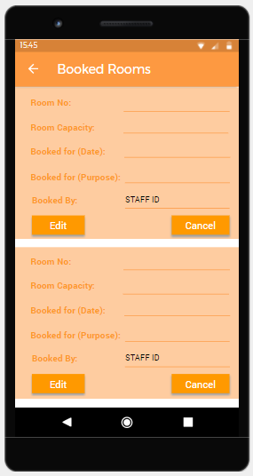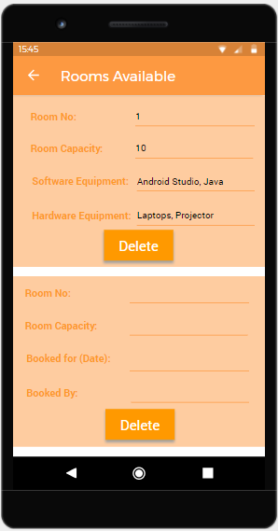

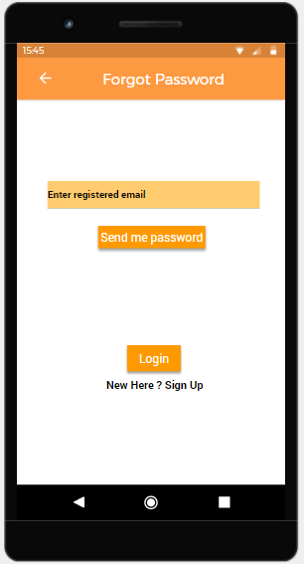

1. **Database (ERD)**

Database is absolutely an integral part of software systems. To fully utilize ER Diagram in database engineering guarantees you to produce high-quality database design to use in database creation, management, and maintenance. An ER model also provides a means for communication.

**ERD Diagram**

***To be Done***

* 1. **Database Schema**

|  |
| --- |
| ***To be Done*** |

1. **Web Calls**

***To be Done***

**Login**

|  |  |  |  |
| --- | --- | --- | --- |
|  | ***To be Done*** | | |
|  |  | | |
|  |  | | |
|  |  | | |
|  |  |  |  |
|  |  |  |
|  |  |  |
|  |  |  |
|  |  |  |

1. **References**

***To be Done***

1. **Glossary**

|  |  |
| --- | --- |
| **24/7** | 24 hours a day, 7 days a week |
| **App** | Application |
| **System** | Mobile Application |
| **User** | Teachers/ Pedagogical Counsellors/ Other Staff members |

***To be Done***